**4%**

**Using your textbook, labs and lecture notes to complete the following test in 4 hours.**

**All code submitted must be your original work. Code must be uploaded to GitHub in the HandsOnTest/CH10 folder with the solution name HOT10 for grading.**

**EX1 [100 pts]**

Write a GUI application that allows the user to design a card.

* The user can select from at least 3 different occasions.
* The user can select from at least 2 different styles for each occasion.
* Each card style has a different base cost.
* The user can choose to add an envelope for 25 cents.
* The user can choose to add a stamp for 50 cents.
* The user can choose to add a custom message for 25 cents.
* The user can only enter a custom message if the checkbox is checked.
* The user can preview their custom message on the card.
* *Highlight the field that the user is currently editing by changing the background color to LightGreen.*
* Create a **Occasion** class that contains a name and an array of styles.
* Create a **Style** class that contains a name, price, and background image.
* Create a **Order** class that contains all of the information about the user's order and the total price of the order.

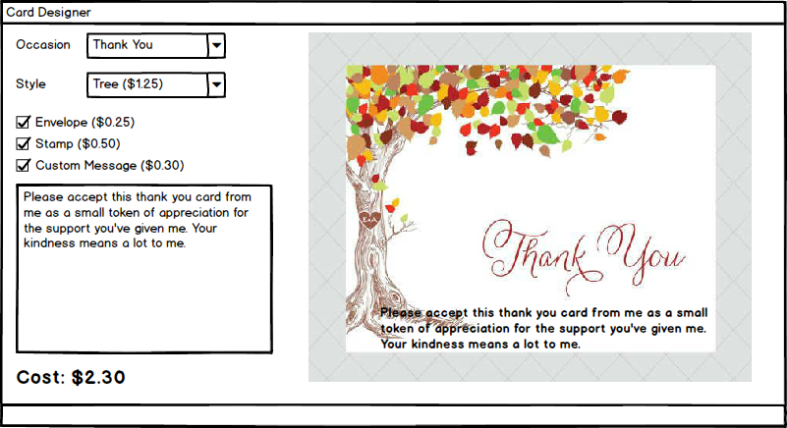

**EX1 [100 pts]**

* Controls are laid out as expected – 5 pts
* Tab order is configured – 1 pts
* Control names follow naming conventions – 2 pts
* Variables, Constants, and Fields follow naming conventions – 2 pts
* Properties follow naming conventions – 2 pts
* Methods follow naming conventions – 2 pts
* Classes, Enumerations, and Interfaces follow naming conventions (including form) – 2 pts
* Occasion class implemented and integrated – 10 pts
* Style class implemented and integrated – 10 pts
* Order class implemented and integrated – 10 pts
* **User can select from at least 3 different occasions – 5 pts**
* **User can select from at least 6 different styles – 5 pts**
* **The base cost of the card is calculated and updated correctly – 10 pts**
* The cost of an envelope is properly accounted for – 5 pts
* The cost of a stamp is properly accounted for – 5 pts
* The cost of a custom message is properly accounted for – 5 pts
* **Only the currently active field is highlighted – 7 pts**
* The user can only enter a custom message if the checkbox is checked – 5 pts
* The user can preview their custom message on the card – 7 pts